ASSIGNMENT COVER PAGE

Project Management 3 – PRM370S / PRM371S / PRM372S

TERM 3 – Research Assignment

Declaration
By signing the declaration below, I agree that plagiarism is wrong. Plagiarism is to use another’s work and pretend that it is one’s own.
I have used the Harvard convention for citation and referencing. Each contribution to, and quotation in, this project from the work(s) of other people has been attributed, and has been cited and referenced.
In addition, I assert that this is an original piece of research.
I will not allow anyone to copy this work with the intention of passing it off as their own work.

Student No.: 217299695______________ Group No.: 3E__________

Name: Clayton Claassens_______________________________________________

Signature: _______________________

Date: 14 October 2019_______________________

Introduction
The triple constraint, sometimes referred to as the project management or the iron triangle, have been a topic of interest as a huge number of projects seem to fail, which also leads to the failure of multiple businesses as projects need to bring value to the business. As this puts the consistency of the Triple Constraint under scrutiny, project managers have taken different approaches to solve this problem with the triple constraint framework. This study analyzes the consistency of the triple constraint and how it can be modified in order to reach the project objectives as well as add value to the business. It questions the focus areas of the triple constraint. This study will be conducted through the use of articles published in journals as well as information gather from websites. The goal of this study is to inform project managers that the focus areas of the classic triple constraint is not the only aspects you need to balance in order to reach the project goals as well as add value to your business.

Literature Review

The Triple Constraint
When undertaking a project, the project management theory suggests that any project is constrained by three key elements: Time, Cost and Scope. One name used to describe these three key elements are “The Triple Constraint”, another popular name is “The Iron Triangle”. The Iron Triangle was originally conceived as a framework to enable project managers to evaluate and balance the competing demands of Cost, Time and Quality within their projects (Ebbesen and Hope 2013 cited in Atkinson 1999). (Hassan, Adeleke, Taofeec 2019 cited in Dobson 2004) further explains the triple constraint as a triangle of time, cost and performance that borders on how every project must be achieved. Subsequently the Triple Constraint has become the de-facto method to define and measure project success, with the general perception amongst project managers that a successful project is based upon these three criteria alone (Ebbesen and Hope 2013 cited in Shenhar and Dvir 2007; Duggal 2011).

Project Success
According to (Maffeo 2018) because all three constraints relate directly to one other, achieving them in tandem yields a quality project. (Hassan, Adeleke, Taofeec 2019 cited in Greer 2008) further elaborates that project managers must focus on three dimensions of success so as to complete all projects on time, within the estimated budget and delivering quality product or services acceptable to the sponsors or stakeholders. However, according to (Rugenyi 2015 cited in Shenhar & Dvir, 2007) the emphasis and project goals may differ from project to project, but the total responsibility for overall project success rests on the shoulders of the project manager, the one who is running the project day-to-day . As there’s no way to exactly measure the success of a project, we can thus say that project success is in the eye of the stakeholders. While we would like to say that we have a clear set of goals by using the triple constraint, we see that this varies based on the perspective of the stakeholder (Cuellar 2010).

(Maffeo 2018) suggest that that the iron triangle has some limitations, one of them being that the iron triangle doesn’t account for how well a project achieves its business goals. (Maffeo 2018) further states that if your project doesn’t achieve the business goals that its stakeholders need, then its quality is questionable. That’s one reason why critics call the iron triangle a simplistic model that doesn’t address what today’s project managers need. According to (Baratta 2013) a poor mental model prevents progress and the Triple Constraint has done just that. It influences how we measure projects. We have used the measures of delivered functionality, actual cost and schedule versus planned for as long as can be remembered. Yet, despite the best efforts of many, we continue to achieve relatively poor project results. Further (Baratta 2013) suggests that the classical Triple Constraint, as a tool for measuring project success, is inadequate as it does not allow us to measure how well we have succeeded with respect to the business opportunity. It measures the wrong things and diverts our attention away from the real opportunities.

Modifying the Triple Constraint

The Value Triple Constraint

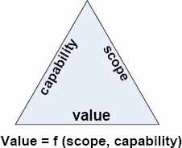
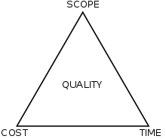
Figure 2: Triple Constraint
Figure 1: The Value Triple Constraint

According to (Baratta 2013), the Triple Constraint model’s key problem is that it actually consists of two factors and not three. He explains that Cost usually refers to expenditures or long costs such as employee costs. When calculating employee costs, time worked/duration is multiplied by cost. Therefore the time factor is part of cost and not a separate factor. The Value Triple Constraint replaces the cost and time factor with “Value”. Value is a function of scope and the capability of the process used to deliver the project. (Baratta 2013) states that the Value Triple Constraint goes beyond the individual project and allows project managers to measure portfolios as well as the project management process over a certain time period. According to (Baratta 2013) the updated version of the Triple Constraint moves the focus away from project managers and focuses more on project management as a whole.

The Project Diamond
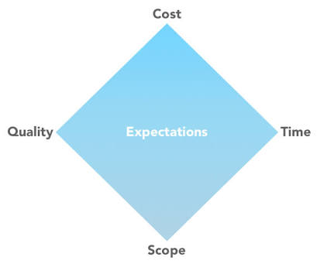

An increase in digital projects made an impact on the classic Triple Constraint and a newer version was introduced, The Project Diamond. Customer expectation have been made the central theme and quality have been added to the model as one of the constraints. According to (Skillpoint 2018) customer expectations have been placed central because digital projects are considered successful if the customer expectations have been met or exceeded. Quality is placed as one of the constraints as this is in direct relation to the customer expectations.

The Star Model
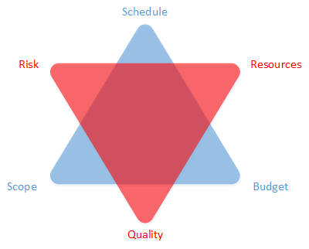

The Star model, also based on the Triple Constraint, outlines the six key constraints, rather that all of them. According to (Skillpoint 2018) suggests that if one of the constraints is effected, it is highly likely that one of the other constraints will be impacted. The triple constraint should not be treated as a rule, rather as a possibility (Skillpoint 2018). (Skillpoint 2018) suggests that the Star model provides a better representation of the project constraints and the theory recognizes the changing nature of the constraints throughout the lifecycle of a project. Therefore the Star model provides a good foundation for projects, highlights the importance of the ongoing management of these six constraints, and notes the likelihood of constraint changes through the lifecycle of the project.

Modern Criticism
The inconsistency of the Triple Constraint caused much evolution since the introduction of the Classic Triple Constraint. Newer versions take more constraints into consideration as the three stipulated in the Triple Constraint does not suffice when balancing project constraints as a project have more constraints of equal importance that should be monitored during ongoing projects. Project managers should take the business value added by the project in consideration when improving on the triple constraint model as projects are seen as unsuccessful when adding no, or not enough business value on completion of the project. Considering the improvement on successfully completing a project, the improved triple constraint versions makes it easier for project managers to identify and monitor changing constraints in order to complete the project successfully.

Conclusion
The triple constraint fills such a big role in project management that it cannot be replaced, rather only be improved. The classic triple constraint framework has been rendered outdated and project managers should look at alternative newer models based on the triple constraint in order to balance constraints more efficiently. In conclusion, the triple constraint still play a big role in project management and more research should be conducted on how to modify the triple constraint in order to measure business value added by the project.

Findings
Project managers have tried so hard to master the balancing of the triple constraint, they started seeing it as a rule. The triple constraint should not be seen as a rule or a model to measure project success. As the triple constraint suggests that change of one constraint is likely to have an impact on another constraint, it suggests that there is a possibility of change and not a fact.

Bibliography
Baratta. “The Triple Constraint, A Triple Illusion .” Performance Innovation (2006): 6. Document.
Cuellar. “Assessing Project Success: Moving Beyond the Triple Constraint.” North Carolina Central University (2010): 28.
Ebbesen, Balshoej, Hope, Alex. “Re-imagining the Iron Triangle: Embedding Sustainability into Project Constraints.” PM World Journal (2013): 13. Document.
Hassan, Adeleke, Taofeeq. “The Effects of Project Triple Constraint on Malaysia Building Projects .” Social Science and Humanities Journal (2019): 1238. Document.
Maffeo. lab.getapp.com. 15 September 2015. Website. 10 October 2019.
Rugenyi. “Assessment of the Triple Constraints in Projects in Nairobi: The Project Managers’ Perspective .” International Journal of Academic Research in Business and Social Sciences (2015): 16. Document.
Skillpoint Blog. Skillpoint. 19 September 2018. 10 October 2019.

ASSESSMENT RUBRIC
Criteria and Qualities | Not Achieved  0 - 4 | Achieved  5 – 7.5 | Excelled  7.6-10 | Mark Obtained | Moderated Mark
Introduction: Problem statement (10%) | Neither implicit nor explicit reference is made to the topic or purpose of the article. | Readers are aware of the overall problem, challenge, or topic of the article. | The topic is introduced, and groundwork is laid as to the direction of the article.
Body:  Flow of the review (10%) | The summary appears to have no direction, with subtopics appearing disjointed. | There is a basic flow from one section to the next, but not all sections or paragraphs follow in a natural or logical order. | The summary goes from general ideas to specific conclusions. Transitions tie sections together, as well as adjacent paragraphs.
Coverage of content  (50%) | Major sections of pertinent content have been omitted. The topic is of little significance to the course. | All major sections of the pertinent content are included, but not covered in as much depth, or as explicit, as expected. Significance to the course is evident. | The appropriate content in consideration is covered in depth without being redundant. Sources are cited when specific statements are made. Significance to the course is unquestionable.
Clarity of writing and writing technique  (10%) | It is hard to know what the writer is trying to express. Writing is convoluted. Misspelled words, incorrect grammar, and improper punctuation are evident. | Writing is generally clear, but unnecessary words are occasionally used. Meaning is sometimes hidden. Paragraph or sentence structure is too repetitive. Few spelling, grammar, or punctuation errors are made. | Writing is crisp, clear, and succinct. The writer incorporates the active voice when appropriate and supports ideas with examples. No spelling, grammar, or punctuation errors are made.
Conclusion:  A synthesis of ideas and application (10%) | There is no indication the author tried to synthesize the information or make a conclusion based on the literature under review | The author provides concluding remarks that show an analysis and synthesis of ideas occurred. Some of the conclusions, however, were not supported in the body of the report. | The author was able to make succinct and precise conclusions based on the review. Insights into the problem are appropriate. Conclusions are strongly supported in the review.
Citations/References:  Proper Harvard format  (10%) | Citation for the article did not follow Harvard format and was missing essential information. | Citation for the article did follow Harvard format; however; a few (2) errors in essential information were evident. | Citation for the article did follow Harvard format. Essential information was accurate and complete.
NAME  STUDENT No. |  | DATE |  | FINAL MARK |  | MODERATED MARK

